Four Corners

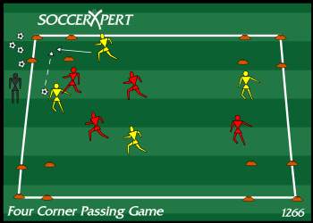
Drill Objective:
The Four Corners Passing Game is a great soccer passing drill to focus on changing the point of the attack, and timing of runs and passes.

Drill Setup:
- In a 40X40 yard area, create four grids that are about 5x5 yard in each corner of the larger grid.
- Split the group into two teams and put one team in an alternate color.

Drill Instructions:
- While each team is in possession of the ball, this team should pass among their teammates to keep possession.
- A point is scored by passing the ball to a teammate that is inside one of the smaller corner grids.
- The teams can score in any of the corners. However, they cannot score in the same area twice in a row.

Drill Coaching Points:
- Focus on the weight and accuracy of the passing
- Make sure players without the ball are supporting the player with the ball at all times
- Make sure the timing of the runs and timing of the pass are in sync.
- Make sure players change the point of attack and are not forcing passes into congested areas

Drill Variations
- Do not allow players to stand inside the grids waiting for a pass. Instead, instruct the players to work on the timing of the runs and timing of the pass to connect inside the grid.
- Change the scoring rule and only award a point when a give-and-go is performed with the player that is in the grid.

